- Event description is appearing like this.
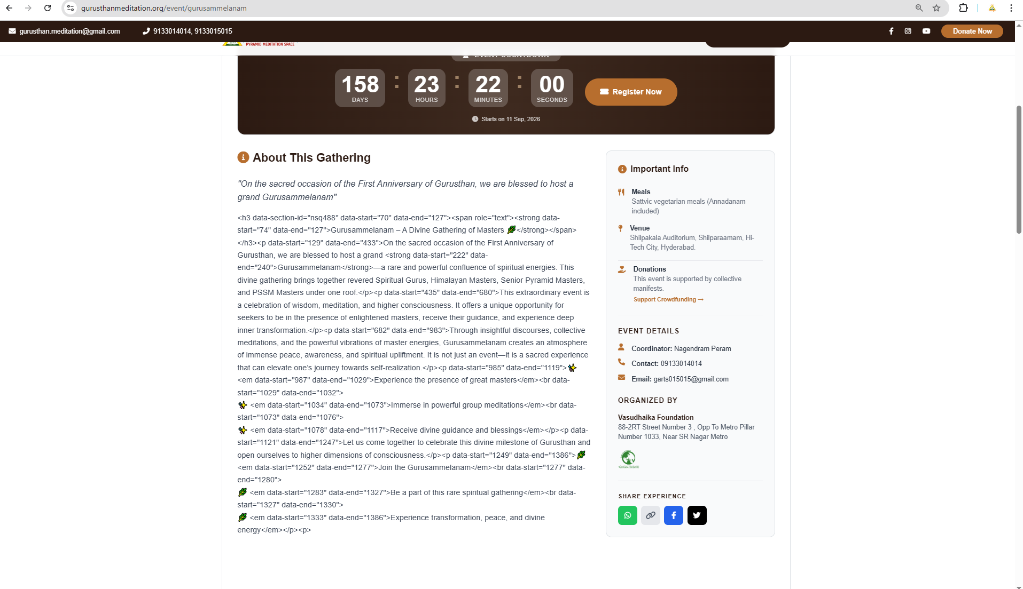
- Updating the event details in day wise schedule but not reflecting in Home Page.

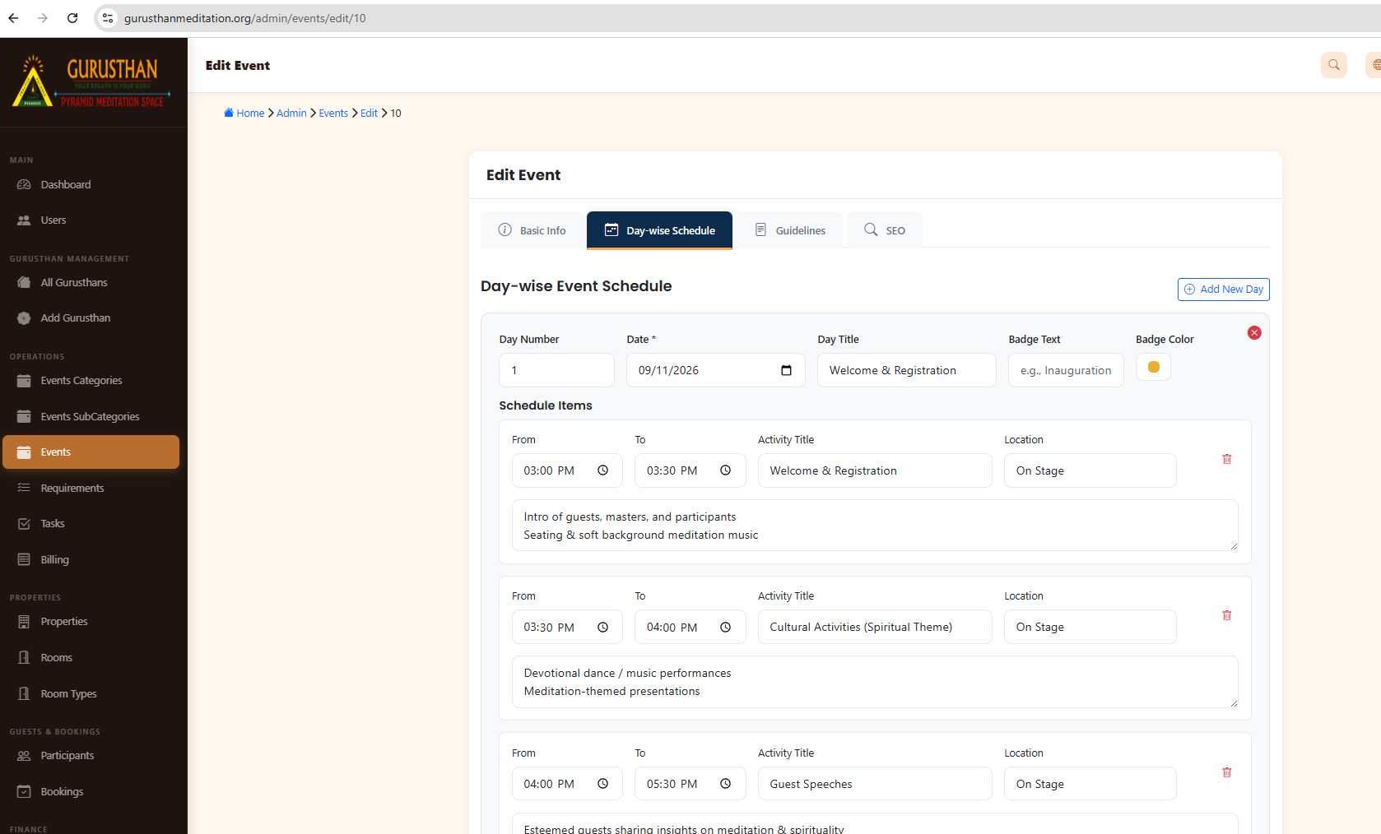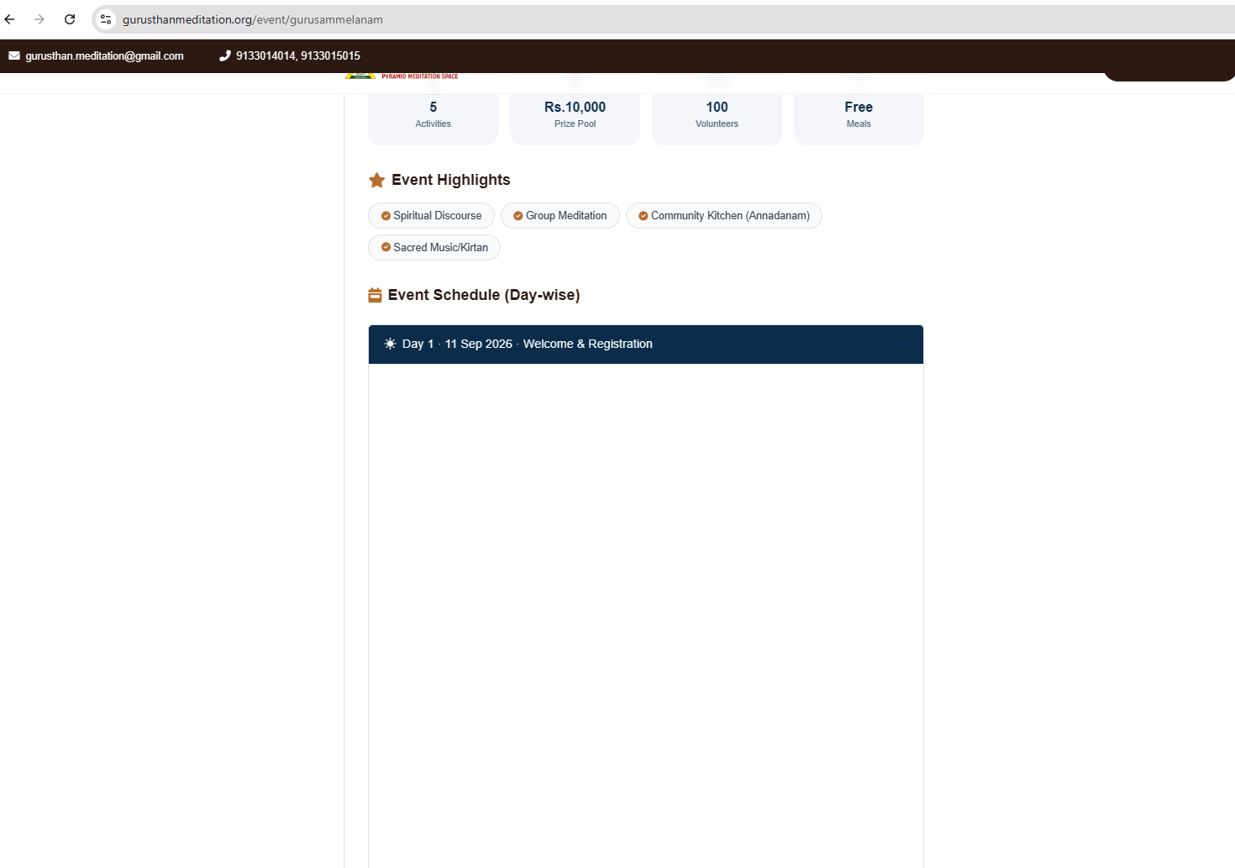

- Provide option to update Event highlights
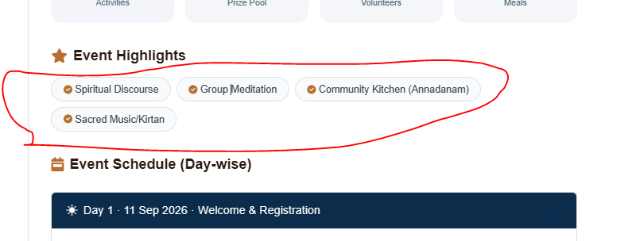

- Provide option to update Event Discussions, Attenders Details and Event Guidelines and Location. Also Change the ‘Explore More Gatherings’ category Events (Old data reflecting)
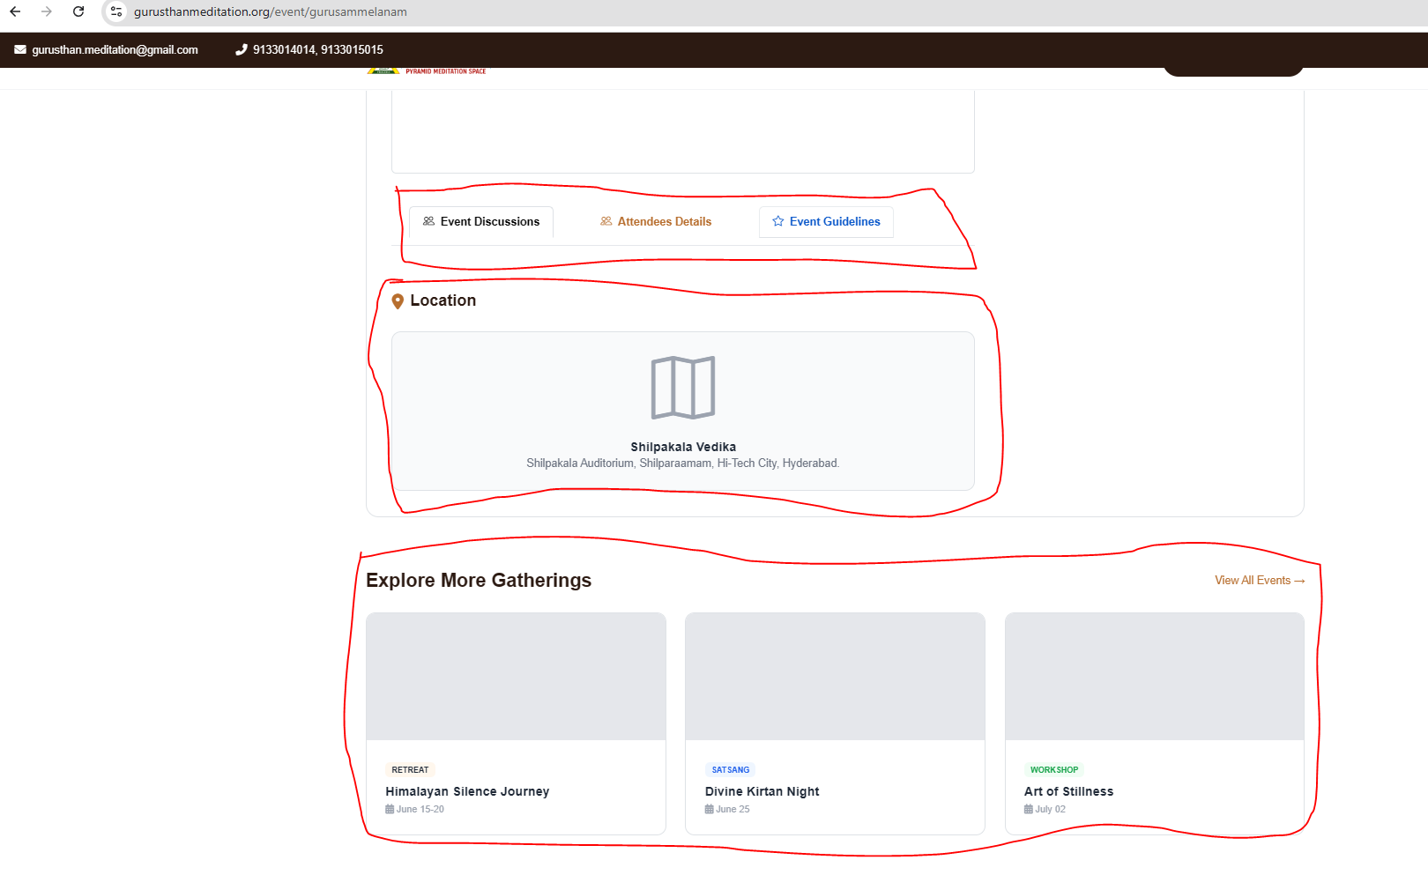

- Provide option to update Sacred Experiences Shared.
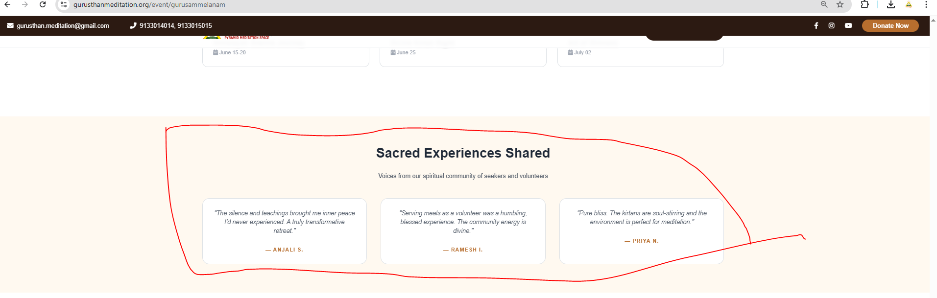

- Required facilities in marked places
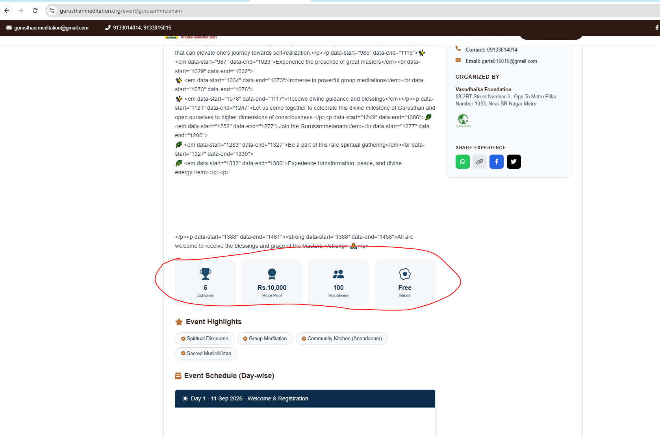

- Prize Pool need as progress Bar like this.
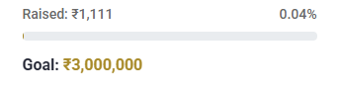
- Contribution button is inactive.
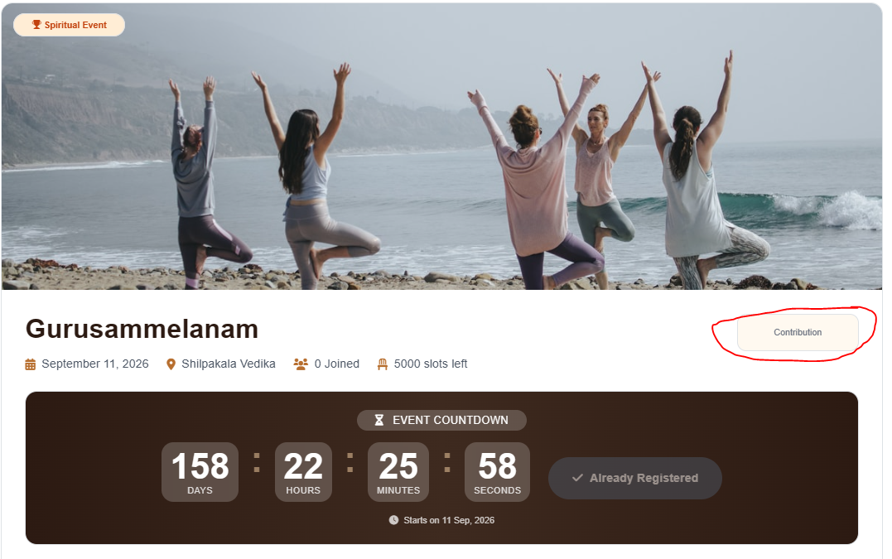
- When click the contribution button need to mention the below particulars
  - Estimation Amount (amount mentioned as Unit)
  - 1 unit = Some amount
  - Volunteer Registration
- In each event provide Volunteer Registration Option. (Register as Volunteer for this Event)

- Provide Event Category as below:
Main category: Food,
For each and every main category have the below kind of sub categories. (Particulars, Status, assigner to, Mobile No, remarks)
Please provide option for main department and sub categories
Sl.No. | Particulars | Status (in drop down) | Assigned to | Mobile No. | Remarks
1 | Food Menu | Completed | Display Registered volunteers list in dropdown | Display Registered mobile no.
2 | Cook Confirmation | Pending
3 | Cutting People Availability | Not yet started
4 | Kitchen Area Availability | Under process
5 | Vessels Booking for cooking & food counter
6 | Plates & Glasses
7 | Drinking Water for Cooking
8 | Water for Cleaning
9 | Persons for Washing Vessels & Cleaning Premise
10 | Tables
11 | Groceries
12 | Vegetables
13 | Dustbin Covers
14 | People for Food Arrangement
15 | Food Serving Volunteer Class
16 | Vessels Handover

